For Immediate Release-Nov. 15, 2010
Contact: Mindy Giles/Swell Productions
916.447.6508 mingiles@gmail.com
www.swell-productions.com

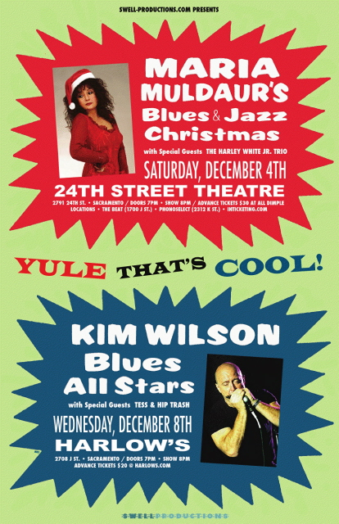
Two “Yule That’s Cool” National Concerts in December
from Swell Productions!!

(Sacramento, USA) Swell Productions brings a Yule That’s Cool to Sacramento in December with two great national blues and jazz concerts. Tickets are on sale now.
On Saturday Dec. 4, America’s First Lady of Roots Music, Maria Muldaur brings her exquisite jazz/blues chops and hip holiday song choices for one night only to:
The 24th Street Theatre @ The Sierra 2 Center for Arts & Community
2791 24th St.
Sacramento, CA 95818
Doors:7 PM
Showtime: 8 PM
Special Guests: The Harley White Jr. Trio
Advance Tix: $30 /At the Door: $35
Tix Available @ www.inticketing.com, The Beat,
Phono Select Records (2312 K Street) and all Dimple locations.

Says Maria: “I'm assembling my "A Team" of jazz players for an evening of hip Blues and Jazz Christmas toons. There will be no sappy, overdone, pedestrian Christmas toons here, folks! Only my special collection of rare gems in the Blues & Jazz idioms. Songs made famous by Louis Armstrong, Eartha Kitt, Louie Prima, Charles Brown, Mabel Scott, May West and many more! Come on down, bring your friends and loved ones, get a jump start on your Holiday Cheer & be a part of the show!”
Some of the featured toons!!
"Boogie Woogie Santa Claus" "Yule That's Cool"
"Santa Baby" "What Will Santa Claus Say"
"At The Christmas Ball" "Christmas Night in Harlem"
"Merry Christmas Baby" "Zat You Santa Claus"
"Rockin' Winter Wonderland"
Sporting one of the slinkiest "come-hither" voices around, Maria Muldaur still is best known for her 1974 mega-hit "Midnight at the Oasis." She's since strutted her stuff on a number of earnest "blues-mama" belters and assorted projects, and her pliant voice, sexy sense of humor and encyclopedic grasp of roots music are on full display in this very special holiday show.
www.mariamuldaur.com www.thehwjo.com/fr_home.cfm
~~~~~~~~~~~~~~~~~~~~~~~~~~~~~~~~~~~~~~
And on Wednesday, Dec. 8…Harmonica player, songwriter, and singer Kim Wilson is as much a student and historian of classic blues as he is one of the world’s top harmonica players. He has, across 35+ years of professional playing, as leader of The Fabulous Thunderbirds and much beyond, become a brilliant torchbearer of the blues genre. He will be appearing in Sacramento for one night only,
Wednesday, Dec. 8
Harlow’s
2708 J Street/Sacramento, CA
Doors: 7 PM
Showtime: 8 PM
SPECIAL GUESTS: Tess & Hip Trash
Advance: $ 20 / At the Door: $25
www.harlows.com

Although he's long been known as the charismatic frontman for the Fabulous Thunderbirds, Wilson's solo albums -- which feature bands of his own choosing for different tracks -- is where the genius in his work shows through most clearly. His Blues All Stars band show off that genius. “Only first-rate musicianship allows Wilson to cut a wide swath in order to uncover all the elements of true blues music; songs and styles that may go by the wayside with Wilson's other band, the guitar forward Fabulous Thunderbirds ... Kim is the one with the most signature sound, style, and presentation. He looks just as comfortable without a harp in hand all while sweating out a soulful vocal number by Little Milton. Wilson is either gracious, yes, or just smart enough to let his band do their work.” His appreciation of the genre too, has led him to collaborations with other great artists, continuing on to sessions with Eric Clapton, touring with Bonnie Raitt, plus getting Grammy nominations for his work on the Cadillac Records soundtrack.
The Kim Wilson Blues All-Stars currently are: Guitarists Billy Flynn and Little Frank, bassist Randy Bermudes (from the Thunderbirds) and drummer Richard Innes, plus piano player Barrelhouse Chuck.
Special guests, Sacramento’ s Tess & Hip Trash, have just had their brand new CD, There’s A Party Goin’ On selected to represent the city. The Sacramento Blues Society chose the CD as their official entry in the 2011 International Blues Challenge CD competition. The event in Memphis is February 1-5, 2011. http://www.blues.org/ibc/#ref=ibc_selfcd
http://www.fabulousthunderbirds.com/ http://parisclayton.com/fr_home.cfm
###############################
MEDIA REQUESTS: For interview arrangements, hi res JPEGS, further information, and upcoming Swell concert info, please Call Mindy Giles/Swell Productions @ 916-447-6508. And please visit our new, revised website @ www.swell-productions.com.

