For Immediate Release-January 5, 2010
Contact: Mindy Giles/Swell Productions
mindy@swell-productions.com
www.swell-productions.com

Sacramento--JUST Announced from Swell Productions!

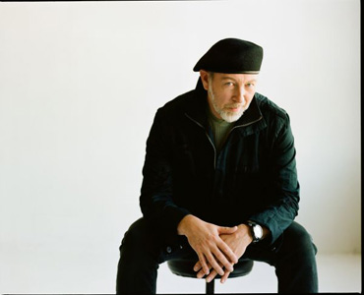

Media Alert: Only 3 NorCal shows-Richard Thompson Sacramento Concert Tickets Go on Sale Jan. 17

"A PERENNIAL DARK-HORSE CONTENDER FOR THE TITLE OF GREATEST LIVING ROCK GUITARIST"
--ROLLING STONE

2010 Grammy Nominated

Richard Thompson Electric Trio
(with Taras Prodaniuk & Michael Jerome)
Special guest: Alex Nelson Acoustic Trio

Wednesday, March 23, 2011
The Ace of Spades (formerly The Empire Events Center)
1417 R St.
Sacramento, CA 95818
6:30 PM doors, 7:30 PM showtime

Tickets go on sale January 17 @ inticketing.com,
Phono Select (2312 K Street/Sacramento)
and all Dimple Records locations

Swell Productions Information #: 916-457-7553
www.swell-productions.com
Tickets: $35 advance, $40 door
General Admission/21+

~Queen Elizabeth II Bestows the Order of the British Empire upon Richard Thompson! (12/30/10)
~Recipient of the Orville Gibson Guitar Award,
The Ivor Novello Award for Songwriting, The 2010 Mojo Les Paul Guitar Award,
The BBC Lifetime Achievement Award,
and a Top 20 slot in The Rolling Stone "All Time Greatest Guitar Players List"
~Curator of the 2010 Meltdown Festival~
"THE 50 GREATEST GUITARISTS EVER" LIST
- Los Angeles Times Magazine

The iconic British folk rock legend is one of the world's most critically acclaimed and prolific songwriters. His work is admired and recorded by such artists as Bonnie Raitt, David Byrne and Elvis Costello. From his teenage years as a founding member of the 1960s pioneering group Fairport Convention to duo work with his then-wife, Linda Thompson, and over 20 years as a solo artist, to scoring Werner Herzog's 2005 documentary 'Grizzly Man', Richard Thompson's astounding body of work includes over 40 albums of lyrical wit anchored by such a singular acoustic and electric guitar delivery that Newsweek recently announced, 'like all genuine art, it satisfies completely.' His new Grammy-nominated CD is DREAM ATTIC ( Shout Factory.)
"In the guitar god firmament, Thompson easily takes a place beside Eric Clapton and Jimmy Page. He has certainly been the most consistently imaginative English plank spanker of modern times." - Daily Mirror
www.richardthompson-music.com

