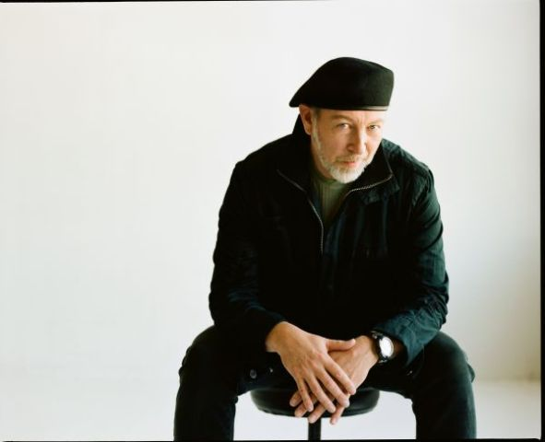 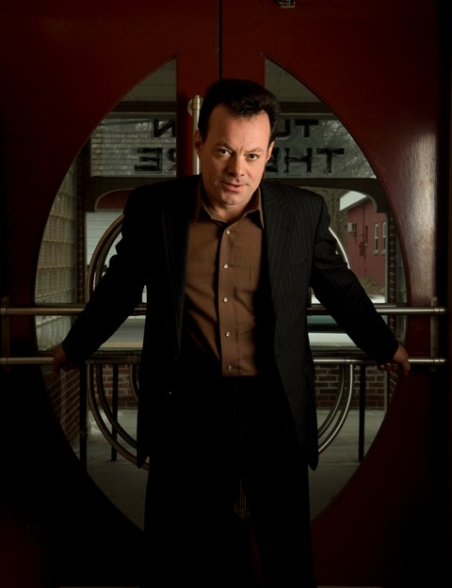
Richard Thompson James Hunter
(Sacramento, CA) Swell Productions brings a very select British Invasion to Sacramento! Legendary guitarist/singer-songwriter Richard Thompson is here Sat., June 30, AND soulman/crooner James Hunter on America's birthday eve, July 3.
The British music legend, Richard Thompson, solo and acoustic, returns to his favorite venue in Sacramento.
Saturday June 30, 2012
24th Street Theatre at the Sierra 2 Center for Arts & Community
2791 24th St., Sacramento 95818
6:30pm doors, 7:30pm showtime
Tickets: $38.50 advance, $40 door
www.inticketing.com/events/203059/richard-thompson/
Special guest, Singer/songwriter Sherman Baker
www.richardthompson.com
For over 40 years, Richard Thompson has been the guitarists’ guitarist, the songwriters’ songwriter,and a consummate artist. As a founder of the legendary British folk-rock group Fairport Convention, through the ’70s releases with his then-wife, Linda Thompson,to his highly successful solo career and work as a session player for other artists, Thompson is amassing an archive of recordings and compositions nearly unequaled in modern music history. He was named one of Rolling Stone Magazine's Top 20 Guitarists of All Time for his acoustic and electric virtuosity. Robert Plant, REM, Elvis Costello, Los Lobos, David Byrne, Del McCoury, Bonnie Raitt, and many others have recorded his work. Consistently extolled as a dazzling live performer, Thompson's live-tour CD Dream Attic received a 2011 Grammy nod. Thompson was appointed Officer of the Order of the British Empire (OBE) in the 2011 New Year Honours for services to music. In April 2012, the Idyllwild Arts Academy Orchestra was joined by Thompson in a world premiere in LA of his chamber music triptych, Interviews with Ghosts.
~~~~~~~~~
James Hunter
Tuesday July 3, 2012
Harlow's - 2708 J Street, Sacramento CA 95816
6pm doors, 7pm showtime
Tickets: $35 advance tickets
www.harlows.com
Special guest, The Harley White Trio
The stunning Grammy-nominated R&B/soul artist we have been trying to get back to Sacramento for over four years. James Hunter had been promoting the revival of classic-era soul for a couple decades before fellow Brits Amy Winehouse, Corinne Bailey Rae, and Joss Stone came along. His command of the idiom has never been less than thorough and convincing-- without knowing that the songs on The Hard Way were newly recorded, anyone might guess that this retro feast was a long-lost gem from 1966. Hunter's voice is equal parts grits and silk, somewhere between Sam Cooke smooth and Bobby "Blue" Bland scorched, and his small combo of sympathetic players could easily have found work in the studios of Hi, Stax, or Chess back when this style reigned.
"Sexy songs to charm your pants off. Sure, James Hunter's music is an intentional throwback to a different era, but he picked a great one: that heady time when Sam Cooke and Jackie Wilson crooned satin-smooth soul over cool jazz/blues arrangements; when a guy could sing simple lyrics and lay on pizzicato strings without a whit of irony. What a wonderful world this could be—especially if you sex up the suave delivery with a stuttering, lo-fi guitar break or James Brown growl. With analog recording, Hunter's buttery voice and primitive Les Paul playing and a muscular double-sax section, this follow-up to People Gonna Talk re-renders the art of musical seduction even more convincingly than Hunter's mentor Van Morrison." --Paste Magazine
~~~~
Media: for more info, hi-res JPEGS, interview arrangement, other downloadable media, please call Mindy Giles/Swell Productions. 916-447-6508. Or write back to mingiles@gmail.com www.swell-productions.com

