For Immediate Release-July 22, 2011
Media Contact: Mindy Giles
916.447.6508
mingiles@gmail.com
www.swell-productions.com

"Blows the doors off!” -Atlantic City Weekly

"The energy of his father, bounding around stage, wound up like a tight coil"
-Las Vegas Sun
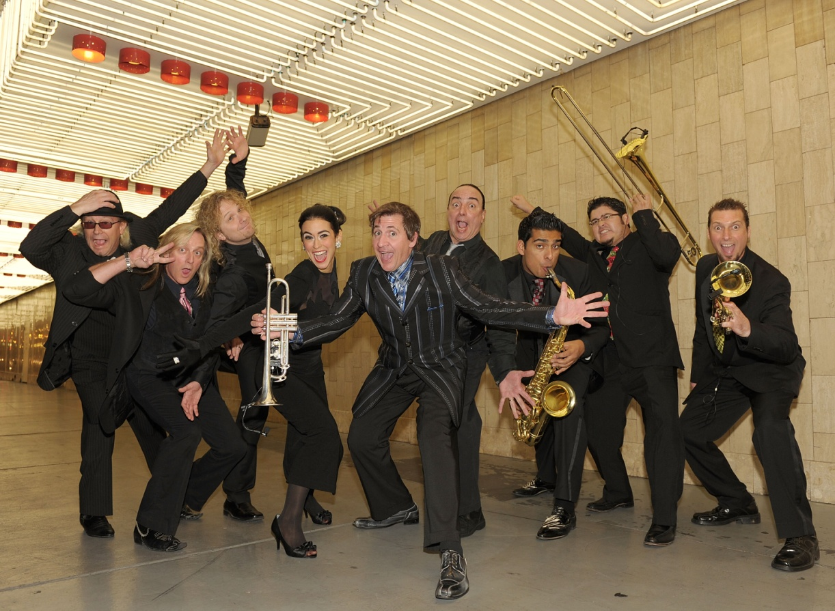
It’s Gonna be a Big Night: Louis Prima Jr. Brings His Jump, Jive
and Wail to Sacramento on Saturday, Oct. 15!

(Sacramento, CA) Swell Productions is proud to announce the hottest dinner/dance concert of the season starring Las Vegas’ Louis Prima Jr. & The Witnesses This sizzling nine piece orchestra starring Louie Prima Jr. and Sarah Spiegel, brings the lauded jump jazz repertoire of his famous father. This Sacramento debut is one night only!

Legendary swing and swagger!” – Robin Leach

Saturday, October 15
Harlow’s
2708 J St.
Sacramento, CA 95816

Open Dance Floor / Limited Seating
VIP Table Seating $45 per person
Dinner available from 5pm to 6:30pm with reservation
Contact Harlow's at 916-441-4693 for table seating/dinner reservations
(Dinner not included in VIP concert ticket price)
General Admission (Standing/dancing) $35
Showtime: 7 PM
Tickets go on sale to the public August 15@ www.Harlows.com
Concert Details: www.swell-productions.com
Swell Productions Info: (916)457-5553
LOUIS PRIMA, JR. brings his famous father's music to life, with an energetic performance and the unique, first hand perspective of being the son of a music legend. It is an exciting stage show, in which you will fall in love all over again with the amazing music, as well as discover some gems that you may not have heard before.

LOUIS PRIMA, JR. carries on the legacy of his New Orleans-born, proudly Sicilian-American father, who was known as the original "King of Swing." The trumpeter, songwriter and bandleader was at the forefront of the rock & roll movement, he was the epitome of the cool, singing and swinging Italian crooner, and he achieved immortality as King Louie in Disney's Jungle Book.
Though he had the first song inducted into the Grammy Hall of Fame, the iconic "Sing, Sing, Sing," it was in Las Vegas where Louis Prima Sr. was best known. Louis Prima and the Witnesses became legendary during the 50s, 60s and 70s. Like most high rollers and celebrities, even the famed Rat Pack were regulars at the "Wildest Show” in Vegas. With hits like "Jump, Jive, an' Wail," "Angelina," "Just a Gigolo," "That Old Black Magic," "Buona Sera," "When You're Smiling" and "Sing, Sing, Sing," Prima Sr. was truly an innovator with a distinctive sound and boisterous presence. His music is timeless, as covers of his classics became modern-day hits for David Lee Roth, Reba McEntire and Brian Setzer. Even Elvis Presley, when asked where he got his wiggle, replied, "From Louis Prima, of course!"

Destined for musical greatness, Louis Jr. began his musical career with drums at the mere age of five. Moving on to piano by eight, Prima Jr. was becoming a virtuoso of all musical instruments, including trumpet and guitar. In 1987 he formed a rock band, in which he was the lead singer and songwriter. Pursuing the rock n' roll dream of a recording contract, Prima's band opened for the likes of Winger. But when the grunge music scene came along, Louis decided to give up on the record business.

Prima Jr. has gone back to his roots / his father's music. And, in the vein of his father, Prima Jr. set out to put together a show with a swinging and rocking band that will "Jive" you crazy with the feel of the "Wildest Show” in Vegas.
Louis Prima, Sr. was a star / a living legend. His name alone commanded top billing for some 40 years. In 2010, honoring his lifelong commitment to the music of the city of his birth, and to commemorate the 100th anniversary of that event, Prima was honored by being the annual poster subject of the New Orleans Jazz and Heritage Festival, in a painting created by artist and singer Tony Bennett, under his birth name Anthony Benedetto.
On July 25, 2010 Louis Prima received a star on the Hollywood Walk Of Fame's 50th anniversary on the year of his 100th birthday. His son, Louis Prima Jr, performed a concert in honor of his father, which included all of Louis Prima's hits.

Louis Prima Jr. is bringing THE LEGENDARY SHOW BACK! The right way, the only way he knows how... to Jump, Jive and Wail!

Louis Prima Jr. Promo Reel: http://www.youtube.com/watch?v=Xs24_194MX0

Media: Please contact Mindy Giles @ 916-447-6508 and mingiles@gmail.com for interview arrangements, hi res color and b/w JPEGS plus other downloadable media, guest passes and info.

