
For Immediate Release-August 29, 2012
Media: Mindy Giles/Swell Productions
mingiles@gmail.com 916-447-6508 www.swell-productions.com
JAZZ BLUES STAR,
CATHERINE RUSSELL
ON TOUR IN SEPTEMBER
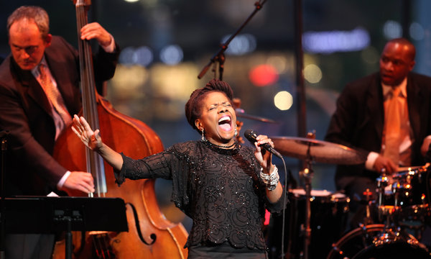
“One of the outstanding singers of our time...she continually shows how
jazz, blues and the Great American Songbook are all different sides of one three-sided coin.”
- Wall Street Journal
Swell Productions and Capital Public Radio present
NYC's Catherine Russell & Her Quartet Friday, Sept. 21 @ Harlow's
Friday, September 21, 2012
Harlow's - 2708 J Street, Sacramento CA 95816
7pm showtime
Tickets: $27.50 advance www.harlows.com www.swell-productions.com
9/19 Catalina Jazz Club Los Angeles, CA
9/21 Harlow's Sacramento, CA
9/22 Monterey Jazz Festival Monterey, CA
9/23 Jazz at Fioli Woodside, CA
9/25 - 9/26 Jazz Alley Seattle, WA
Dynamic vocalist Catherine Russell is the daughter of Luis Russell - Louis Armstrong's longtime music director - and Carline Ray, an outstanding bassist and vocalist. See New York City's Catherine Russell and her great band in Sacramento the night before they headline the 2012 Monterey Jazz Festival! This ever soulful vocalist takes us on a journey; from Harlem dance hall, to Parisian Café, to Store Front Church, to New Orleans Gin Joint, to Uptown Cabaret, blurring distinctions between the carnal and the eternal, in a musical tour de force.
Russell has been an in-demand back-up singer to an impeccable list of artists, including Steely Dan, David Bowie, Cyndi Lauper, Paul Simon, Jackson Browne, Rosanne Cash and The Dukes of September (Michael McDonald, Donald Fagen and Boz Scaggs), with whom she delivers a "soul-dripping version" of "Piece of My Heart" (Salt Lake City Tribune).
In her solo career, Russell is an uncanny interpreter of jazz classics, obscure gems and the Great American Songbook. Her success has made her a regular at major festivals worldwide, as well as at Jazz at Lincoln Center, where she recently sold out two nights and returned as a guest vocalist for an Ethel Waters Tribute, for which she was featured in the New York Times.
Her previous solo albums include 2008's Sentimental Streak and 2010's Inside This Heart Of Mine, which both earned “Vocal Album of the Year” in the Village Voice Jazz Critics Poll. The latter reached No. 7 on the Billboard Jazz Chart, No. 1 on JazzWeek and led to several appearances on NPR's "Fresh Air" and "Weekend Edition." She has also performed on "Late Night with Conan O'Brien".
Strictly Romancin' - World Village 468101
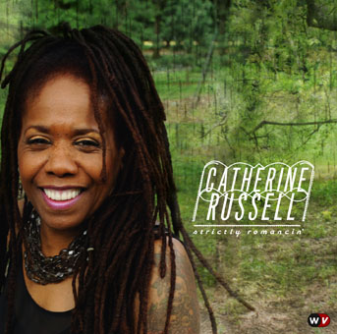
No. 6 Billboard Jazz Chart
March 2012
No. 5 Billboard Traditional Jazz Chart
March 2012
No. 1 iTunes Jazz Chart
February, May 2012
No. 1 Amazon Bestselling Jazz Album
February 2012
No. 1 Jazzweek Chart
March 2012
“Picking favorites isn't easy, but some songs are almost impossible to shake after hearing them so evocatively arranged. Retro excursions are seldom as much fun as listening to Russell reinvigorate 'I'm Checkin' Out, Goom'bye’”- The Washington Post (Editor’s Pick)
"Russell sings in a marvelously full, rich alto and hangs just a hint of a blue scrim over her cheerful, straight-shooting, girl-next-door innocence. Her soulful, R&B triplets on the Lil Green classic "Romance in the Dark" will heat up any Valentine's date"- Seattle Times
"a deliciously diverse collection that travels from sly blues and glorious gospel to rollicking jump blues and spirited swing...Top-shelf stuff."- Minnesota Star Tribune
"one of the most exciting of all new jazz singers. Finding people who aren’t at least a little in love with what Catherine Russell does…would be an interesting scientific experiment...Her fourth disc and perhaps her best."- The Buffalo News
"When Russell goes classic, it's a natural thing, a refreshing thing, a necessary thing and yes, a romantic thing."- San Antonio Express-News
"The whole album is a treasure trove for classic American music fans and for curious listeners."- The Sun Herald
"Russell's voice [is] truly another instrument in the mix. Well, not just another instrument. It's the best one...the album is a sparking collection of great songs by Russell, who is turning into one of the classic voices in song." - Pittsburgh Post-Gazette
http://www.catherinerussell.net/http://www.concertedefforts.com/home/roster/catherine-russell/
Media: Please contact Mindy Giles/Swell Productions 916-447-6508 or mingiles@gmail.com for interview arrangements, promo CDs, and high res color JPEGS. www.swell-productions.com

